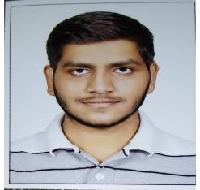**UMARVANSHI NIRMAL NARSINHBHAI**

(B.E Mechanical Engineering)

7698024528

2/1877, Motilalwadi, Sagarampura, Surat-395002

nirmalumarvanshi57@gamil.com

# JOB OBJECTIVE

Well- qualified Quality Control Inspector proficient in documentation, Reporting and compliance standards. Meticulous and methodical professional with a deep understanding of manufacturing and production operations bringing 2 years of related experience.

# EDUCATION

* B.E -MECHANICAL ENGINEERING (2015-2019)

(C.k Pithawala Eng. and Technology)

* H.S.C (SCIENCE STREAM) (2014-2015)

(T and T v High school)

* S.S.C (2013)

(G and G V kadiwala high school)

# WORK HISTORY

* **QUALITY CONTROL INSPECTOR / L AND T MHI POWER BOILER LIMITED (CURRENTY WORKING)**

In this company I am doing fit up inspection, weld visual inspection, inspection before PWHT Dimension as well as Final inspection

* **QUALITY CONTROL INSPECTOR / ARCELORMITTAL NIPPON STEEL LIMITED, HAZIRA**

I had worked in pipe mill as well as plate of this company. In pipe mill I was done Previsual of LSAW pipe OD and ID welding inspection, Final inspection of pipe and plate inspection.

# SKILLS

* Visual inspection of welding
* Pipe Drawing and fabrication Drawing
* Inspection protocols

## Declaration

I here by decide that above information is true to my knowledge and belief Thanking you in anticipation and looking forward to your kind favorable reply at the earliest.